DAA ASSIGNMENT -2
1.bubble sort:
Program: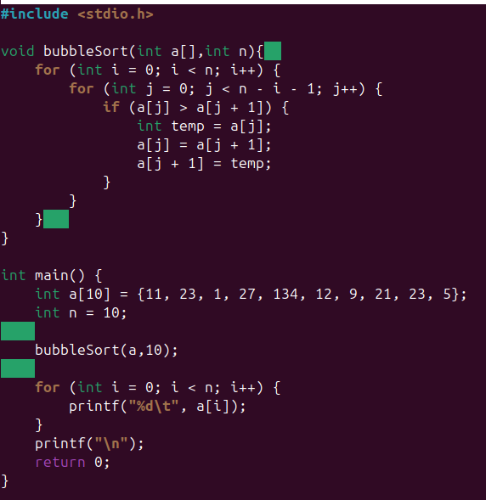
Output:

2.insertion sort:
Program:
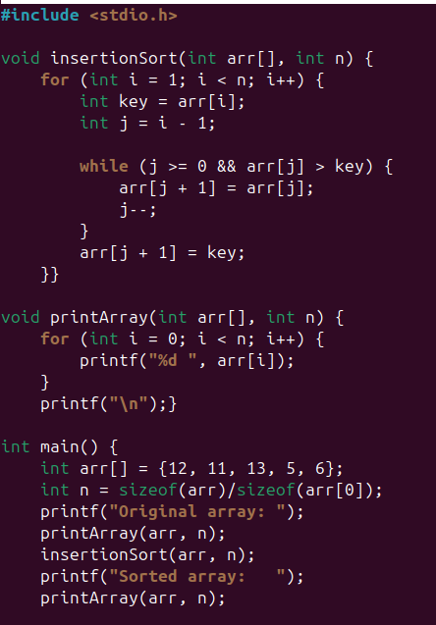
Output:
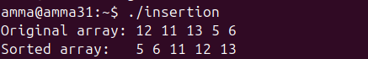
3.selection sort:
Program:
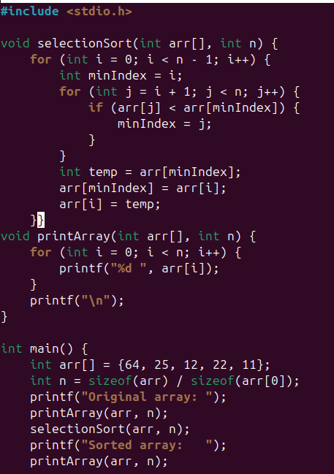
Output:
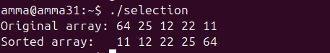
4.bucket sort:
Program:
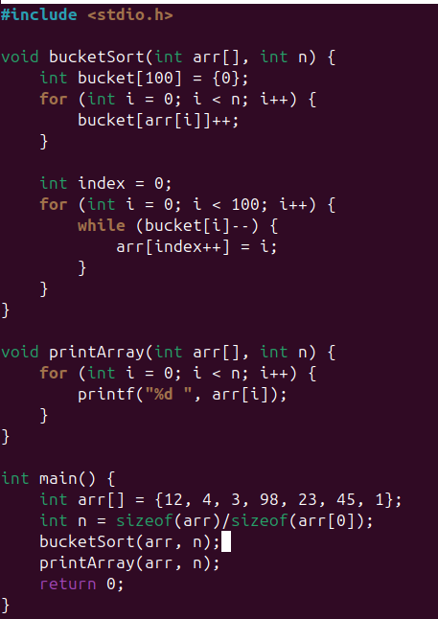
Output:
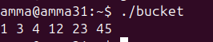
5.heap sort:
Program:
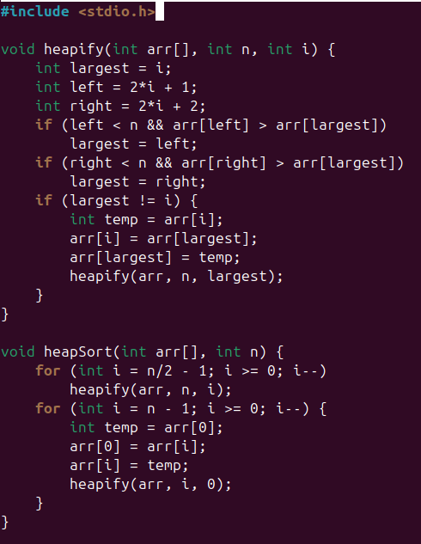
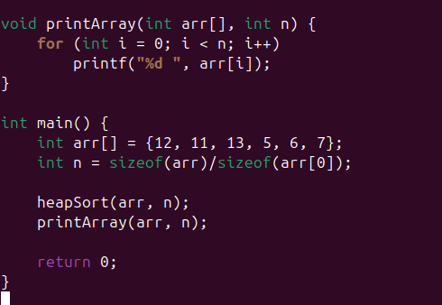
Output:
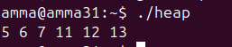

NAME:S.POOJASRI
ROLL NO: CH.SC.U4CSE24235

